**Delonghi Iron (light)**

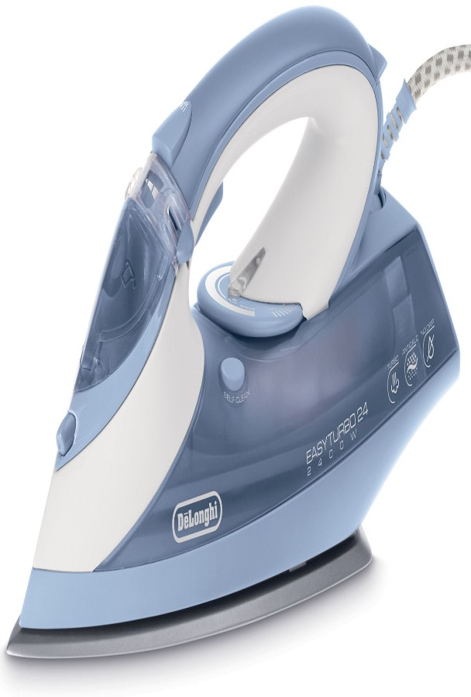

**Key Features  
  
 Heavy Dry Iron  
  Power: 1000 Watts  
  Voltage: 220V  
  Non-Stick Coating Sole Plate  
  Heat-Resistant  
  Easy Operation  
 Price per Unit: $50/-**

**CORPORATE OFFICE**

    1300 E. Control Tower Rd.  
    Suite 216 Block L3  
    Englewood CO 80112  
 Phone: 720.974.7878  
    Toll Free: 1.877.929.7878  
    Email: [info@choicescreening.com](mailto:info@choicescreening.com)